Product Description

Corded Cap Lamps:
A cap lamp is a lamp worn on the head or helmet. It is mostly used in an underground environment, like mines or during outdoor activities, e.g. climbing. The cap lamp or more accurately 'Electric Safety Lamp' is powered by a battery carried on the miner's belt and a cable running up to the lamp fitted to the hardhat.
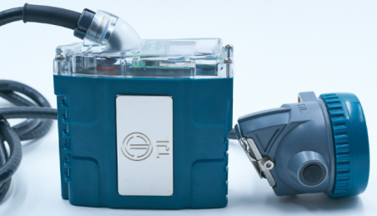
Cordless Cap Lamps:
The cap lamp or more accurately 'Electric Safety Lamp' is powered by a battery inside the headpiece and have no cable. This lamp fit directly on the hardhat.
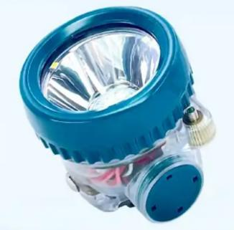

Portable Loco lamps:
The Loco light is a robust, water-resistant luminaire fit for tough, humid and harsh environments. 3-Stage lighting (white spot, red and green light) allows the user to use the luminaire in various applications. Showing danger, indicating direction or safe pass way.
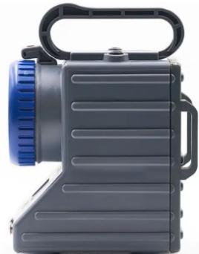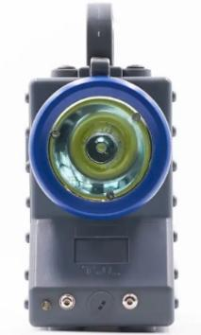

Self-contained Self Rescuers:
A self-contained self-rescue device, SCSR, self-contained self-rescuer, is a portable oxygen source for providing breathable air when the surrounding atmosphere lacks oxygen or is contaminated with toxic gases, e.g. carbon monoxide.
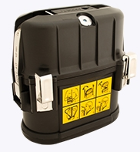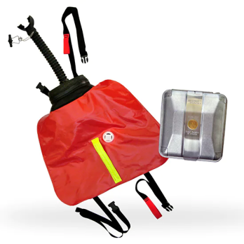

Gas detection equipment:
A gas detector is a device that detects the presence of gases in an area, often as part of a safety system. A gas detector can sound an alarm to operators in the area where the gas or gasses is detected, giving them the opportunity to leave. This type of device is important because there are many gases that can be harmful to organic life, such as humans or animals.
Gas detectors can be used to detect combustible, flammable and toxic gases, and oxygen depletion. This type of device is used widely in industry and can be found in locations, such as on oil rigs, refineries and underground mines.
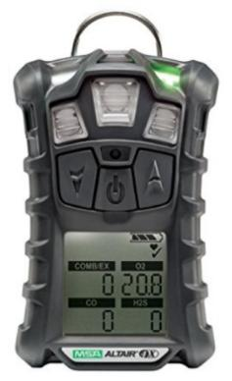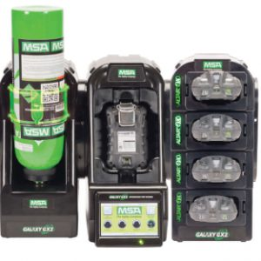

Variety charging racks:
These are charging racks especially designed for the mining industry to charge, cap lamps, cordless lamps, loco lamps, flash lights and storage facilities / capacity can be added to lock away the SCSR with every cap lamp.

Hand held lights:
Portable hand-held electric lamp like flash lights, torches and other lamps that can be carried and moved around by hand.
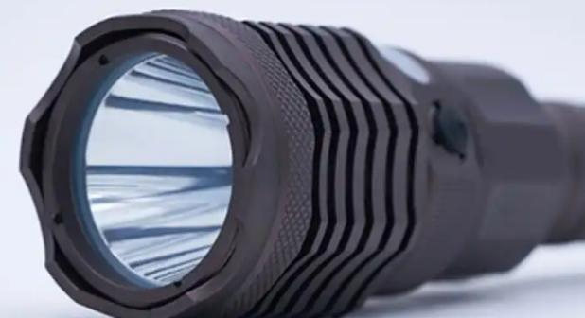

Underground lights:
These are lights especially designed for the underground environment. These lights comply with the DMRE standards

Solar solutions:
Solar power is a self-sufficient renewable energy resource. Installing solar panels on your roof is a clean and safe way to help make the future more sustainable. Solar energy is also an excellent alternative energy solution that can efficiently power your home and help preserve the environment cost-effectively.
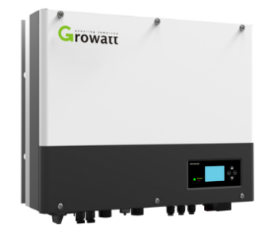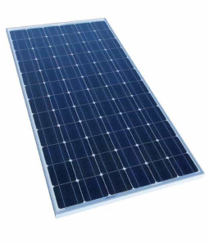

Backup batteries:
A backup battery provides power to a system when the primary source of power is unavailable. Backup batteries range from small single cells to retain clock time and date in computers, up to large battery room facilities that power uninterruptible power supply systems for large data centers.
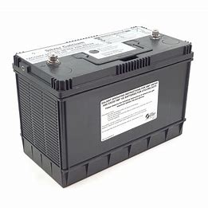

Loco Batteries:
These are batteries that power electric loco’s or other electrical machines in the mining industry. These batteries are also available for electric fork lifts and golf carts.
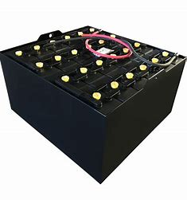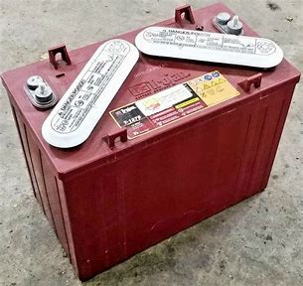

Fire detection:
Fire detection systems are designed to discover fires early in their development fase when time will still be available for the safe evacuation of occupants. Early detection also plays a significant role in protecting the safety of emergency response personnel. Property loss can be reduced and downtime for the operation minimized through early detection because control efforts are started while the fire is still small. Most alarm systems provide information to emergency responders on the location of the fire, speeding the process of fire control

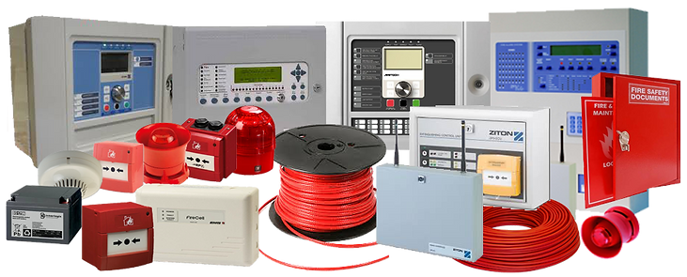

Fire suppression:
Fire Suppression Systems are used to extinguish, control, or in some cases, entirely prevent fires from spreading or occurring. Fire Suppression Systems have an incredibly large variety of applications, and as such, there are many different types of suppression systems for different applications being used today. Systems are available for kitchens, server rooms, Transformer substations, vehicles, conveyor belts any many more.
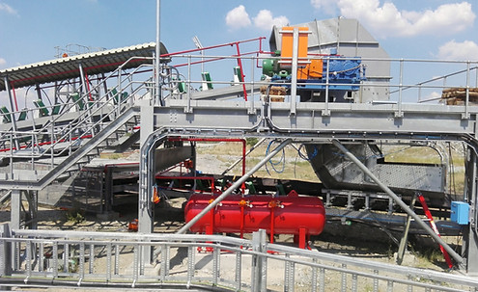

Fire Extinguishers:

We supply and service a comprehensive range of fire extinguishers for application of class A, B & C fires, making it suitable for use in household, automotive and industrial environments.
Our fire extinguishers are SABS 1910 and SABS 1567 certified.

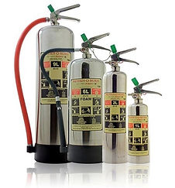

Fire Hose Reels:
These fire hose reels can be used for commercial, industrial and public buildings as a quick response to a small developing fire. Available in; standard, stainless steel and swing type.

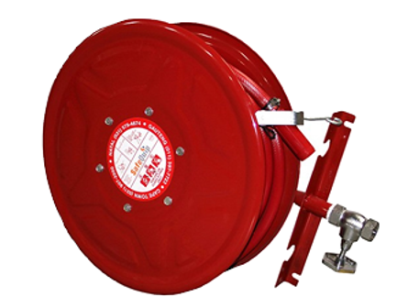

Fire Hydrants:
With a hose attached to the fire hydrant, a valve can be opened to provide a high flow of water to aid you in extinguishing a fire
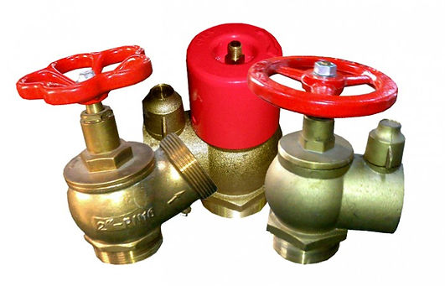

Lay flat Hoses:
We provide a wide range of high pressure fire hoses that allows you to discharge a high volume of water or other fire retardant such as foam for effective fire fighting
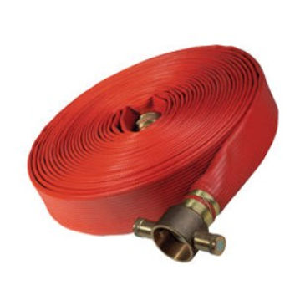
Safety Signage:

Provided in chromadek, photoluminescent and ABS (Acrylonitrile Butadiene Styrene)

I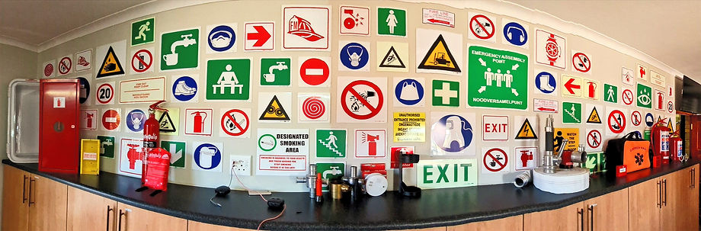

re Hydrants
PDS and CWS systems:
Quality product for equipment that ensures your team gets home safely. The primary focus is Proximity Detection Systems (PDS), sometimes known as Collision Warning Systems (CWS), that offer vehicle-to-vehicle as well as vehicle-to-pedestrian detection. Warning the one of the other one to avoid accidents.

Lamproom management:
A Lamproom is a room or building at the surface of a mine for charging, servicing, and issuing all cap lamps, gas detectors, rescue packs and other safety equipment. This equipment must be managed and comply with certain legal’s and directives from the DMRE. Lamproom management is to ensure that all these legal requirements are followed and that the equipment is safe for use in the underground environment. We supply labour 24/7, 365 days a year and qualified, trained and certified employees to manage the lamp-room on behalf of the client.

Lamproom Audits:
This is done to ensure that the mine comply to the mines COP (code of practice) and DMRE directive, legals and recommendations

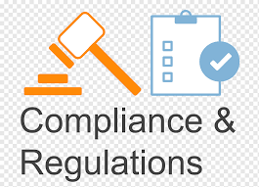

Supply of mobile lamprooms:
Portable lamprooms, it’s a container Lamproom that can be used on new mines or for a specific period on a project and then moved to the next project.
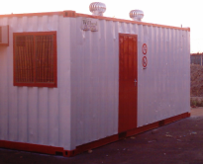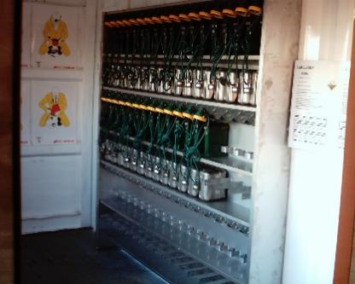

Two-way communication:
Two-way radios and other two-way communication systems for the underground environment.

Personal Protection Equipment:
Personal protective equipment, commonly referred to as "PPE", is equipment worn to minimize exposure to hazards that cause serious workplace injuries and illnesses. These injuries and illnesses may result from contact with chemical, radiological, physical, electrical, mechanical, or other workplace hazards. Personal protective equipment include items such as gloves, safety glasses and shoes, earplugs, hard hats, respirators, coveralls, vests, full body suits and harnesses.

